

**AMERICAN INTERNATIONAL UNIVERSITY-BANGLADESH**

**Faculty of Engineering**

**Lab Report**

**Experiment # 01**

**Experiment Title: Familiarization with a microcontroller, the study of blink test and implementation of a traffic control system using microcontrollers.**

|  |  |  |  |
| --- | --- | --- | --- |
| **Date of Perform:** | 2 February 2026 | **Date of Submission:** | 8 February 2026 |
| **Course Title:** | MICROPROCESSOR AND EMBEDDED SYSTEMS LAB | | |
| **Course Code:** | EEE 4103 | **Section:** | [S] |
| **Semester:** | Spring 2025-26 | **Degree Program:** | BSc in CSE |
| **Course Teacher:** | **Dr. Md. Rukonuzzaman** | | |

**Declaration and Statement of Authorship:**

1. I/we hold a copy of this Assignment/Case Study, which can be produced if the original is lost/damaged.
2. This Assignment/Case Study is my/our original work and no part of it has been copied from any other student’s work or from any other source except where due acknowledgment is made.
3. No part of this Assignment/Case Study has been written for me/us by any other person except where such collaboration has been authorized.

by the concerned teacher and is acknowledged in the assignment.

1. I/we have not previously submitted or currently submitting this work for any other course/unit.
2. This work may be reproduced, communicated, compared, and archived to detect plagiarism.
3. I/we permit a copy of my/our marked work to be retained by the Faculty Member for review by any internal/external examiners.
4. I/we understand that Plagiarism is the presentation of the work, idea, or creation of another person as though it is your own. It is a form of cheating and is a very serious academic offense that may lead to expulsion from the University. Plagiarized material can be drawn from, and presented in, written, graphic, and visual forms, including electronic data, and oral presentations. Plagiarism occurs when the origin of the source is not appropriately cited.
5. I/we also understand that enabling plagiarism is the act of assisting or allowing another person to plagiarize or copy my/our work.

*\* Student(s) must complete all details except the faculty use part.*

** Please submit all assignments to your course teacher or the office of the concerned teacher.

|  |  |  |  |  |
| --- | --- | --- | --- | --- |
| **Group # 06** | | | | |
|  |  |  |  |  |
| **Sl No** | **Name** | **ID** | **PROGRAM** | **SIGNATURE** |
| 1 | SHADIPTA PAL PRANTO | 23-54051-3 | CSE |  |
| 2 | M. A. SHAHRIAR RAHMAN SOUMIK | 23-54040-3 | CSE |  |
| 3 | IMTIAZ BIN ALAM | 23-54037-3 | CSE |  |
| 4 |  |  |  |  |
| 5 |  |  |  |  |
| 6 |  |  |  |  |

|  |  |  |
| --- | --- | --- |
| ***Faculty use only*** | | |
| FACULTY COMMENTS | **Marks Obtained** |  |
|  |
| **Total Marks** |  |



**Table of Contents**

|  |  |
| --- | --- |
| Experiment Title | 1 |
| Objectives | 1 |
| Equipment List | 1 |
| Circuit Diagram | 2 |
| Code/Program | 3 |
| Hardware Output Results | 5 |
| Experimental Output Results | 6 |
| Simulation Output Results | 8 |
| Answers to the Questions in the Lab Manual | 9 |
| Discussion | 10 |
| References | 10 |

**Experiment Title:**

Familiarization with a microcontroller, the study of blink test and implementation of a traffic control system using microcontrollers.

**Objectives:**

The objectives of this experiment were to familiarize students with the basic operation and programming of a microcontroller using the Arduino platform. Specifically, the experiment was conducted to achieve the following objectives:

* To understand the fundamental features and functionality of an Arduino-based microcontroller system.
* To implement an LED blink test using the Arduino board and its built-in delay function.
* To design and implement a basic traffic light control system using LEDs and the Arduino microcontroller.
* To observe and analyze the timing control of digital output pins through programmed delays.

**Equipment List:**

The following equipment and software were used to perform the experiment:

* An Arduino Uno Mini microcontroller board based on the ATmega328P microcontroller
* A breadboard
* Light Emitting Diodes (LEDs) [Red, Green and Yellow]
* Resistors of 1 $kΩ$ value
* Jumper wires for circuit connections
* A USB cable for programming and powering the Arduino board

**Circuit Diagram:**

The circuit was constructed on a breadboard using an Arduino Uno Mini microcontroller board. The LEDs were connected to the designated digital output pins of the Arduino through 1 $kΩ$ current-limiting resistors to ensure safe operation. The anode terminal of each LED was connected to the respective output pin via a resistor, while the cathode terminal was connected to the common ground of the Arduino board. Jumper wires were used to establish all necessary electrical connections between the Arduino board, breadboard, and circuit components.

The circuit configuration was arranged according to the experimental requirements for both the LED blink test and the traffic light control system.

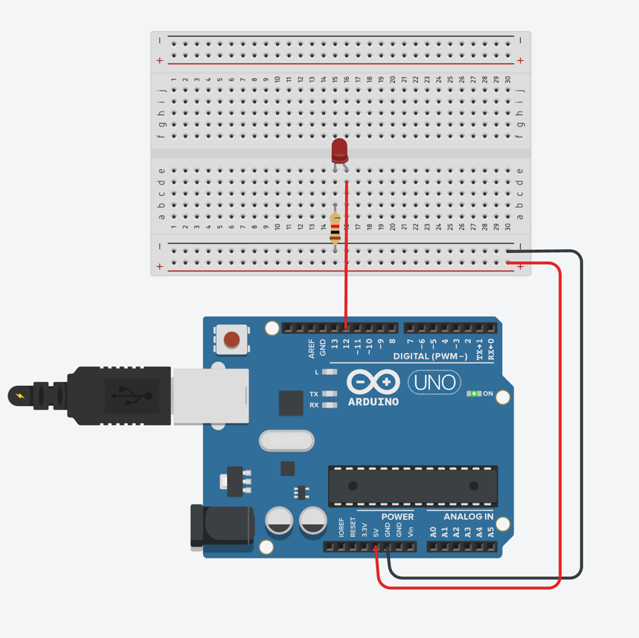

Fig 1: Hardware diagram LED blinking test

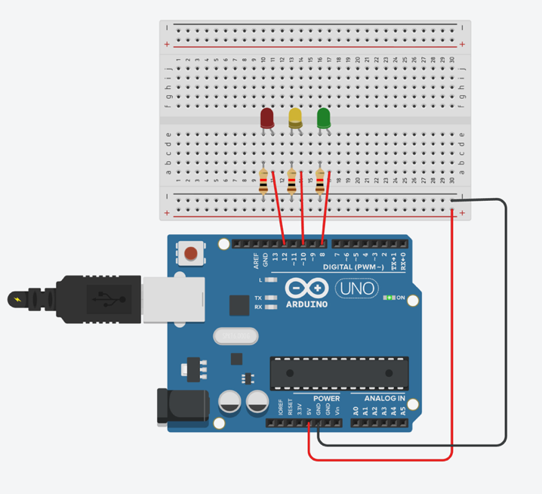

Fig 2: Hardware Diagram Traffic light control system

**Code & Program:**

Two separate programs were written and executed during this experiment, one for the LED blink test and another for the traffic light control system. Both programs were developed using the Arduino Integrated Development Environment (IDE) and uploaded to the Arduino Uno Mini microcontroller board.

**LED blinking:**

The following program was written to verify the basic operation of the Arduino board by blinking an LED at a fixed time interval:

void setup() {

pinMode(12,OUTPUT); // setting the output pin

}

void loop() {

digitalWrite(12,HIGH); // setting the output to HIGH signal

delay(600); // creating a time delay of 600 ms

digitalWrite(12,LOW); // setting the output to LOW signal

delay(500); // creating a time delay for 500 ms

}

**Explanation:**

In this program, digital pin 12 was configured as an output pin using the pinMode() function within the setup() function, which runs only once at the beginning of execution. Inside the loop() function, the LED connected to pin 12 was turned on by setting the pin to a HIGH state and was kept on for 600 milliseconds using the delay() function. The LED was then turned off by setting the pin to a LOW state and remained off for 500 milliseconds. This process was repeated continuously, resulting in a visible blinking effect.

**Traffic Light Control System:**

The following program was implemented to simulate a traffic light control system using red, yellow, and green LEDs:

#define GREEN_PIN 8 // output pin selection for green LED

#define YELLOW_PIN 10 // output pin selection for yellow LED

#define RED_PIN 12 // output pin selection for red LED

int red_on = 6000; // delay for the red LED 6000 ms

int green_on = 3000; // delay for the green LED 3000 ms

int yellow_blink = 500; // delay for the yellow LED 500 ms

void setup() {

pinMode(GREEN_PIN, OUTPUT);

pinMode(YELLOW_PIN, OUTPUT);

pinMode(RED_PIN, OUTPUT);

}

void loop() {

digitalWrite(GREEN_PIN,HIGH);

delay(green_on);

digitalWrite(GREEN_PIN,LOW);

// Blinking loop for the yellow LED

for(int i = 0; i < 4; i++) {

digitalWrite(YELLOW_PIN,HIGH);

delay(yellow_blink)

digitalWrite(YELLOW_PIN,LOW);

}

digitalWrite(RED_PIN,HIGH);

delay(red_on);

digitalWrite(RED_PIN,LOW);

}

**Explanation:**

In this program, symbolic constants were defined for the LED pin numbers using preprocessor directives to improve code readability and maintainability. The delay durations for each LED state were stored in integer variables. During execution, the green LED was activated first for a specified duration, followed by the yellow LED blinking four times using a for loop. Finally, the red LED was turned on for a longer duration before being turned off. The loop() function ensured that this sequence was repeated continuously, thereby simulating the operational behavior of a basic traffic light control system.

**Hardware Output Results:**

The hardware implementation of the LED blink test and the traffic light control system was successfully completed using the Arduino Uno Mini microcontroller board. After uploading the respective programs, the connected LEDs responded according to the programmed logic.

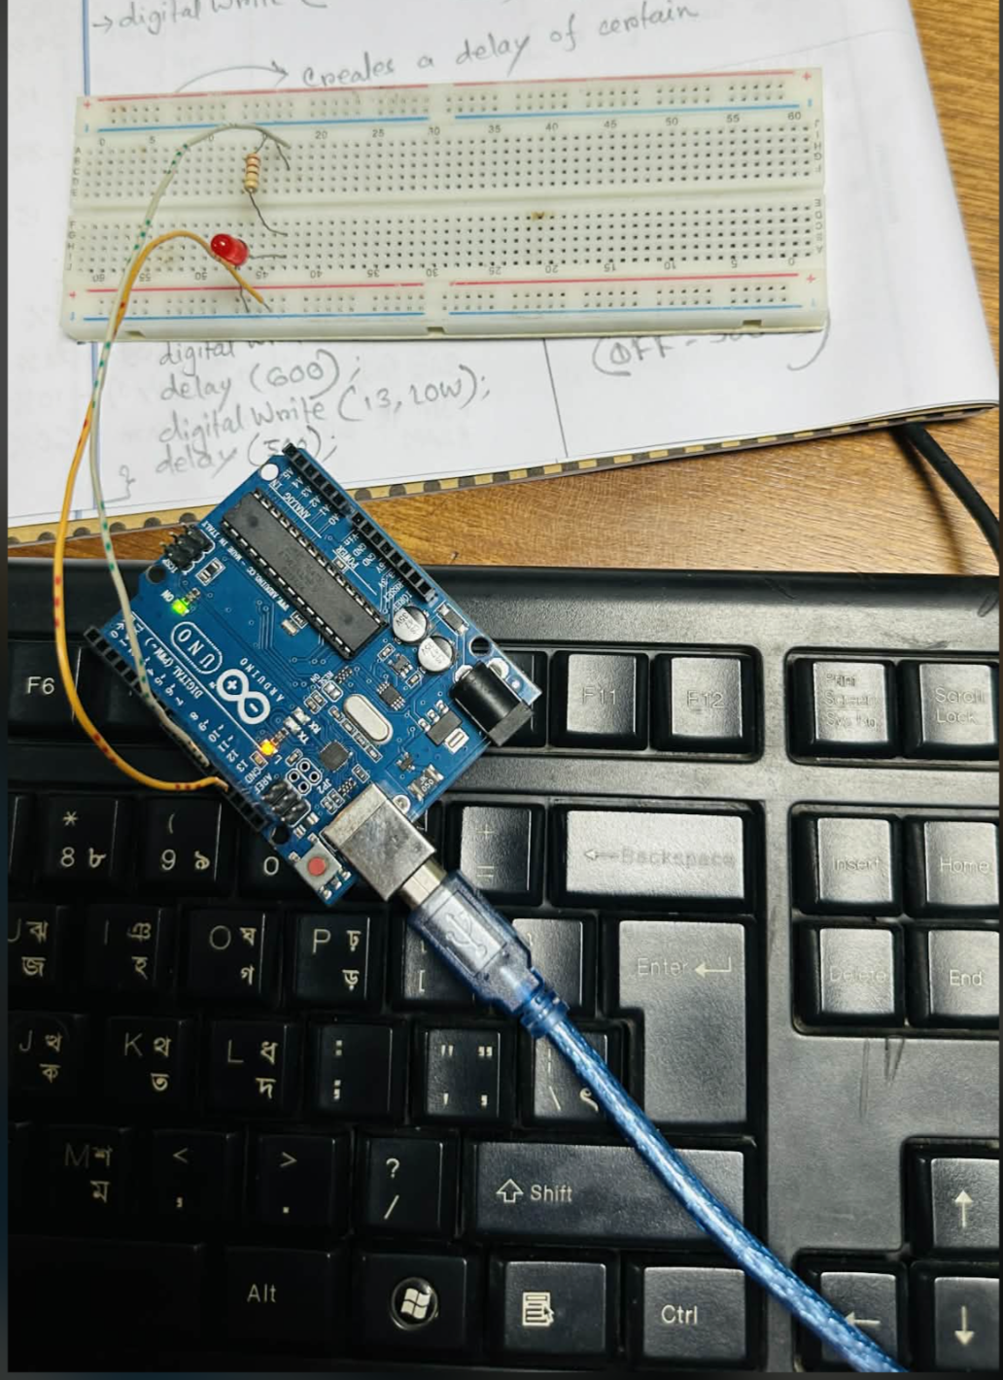

Fig 3: Hardware implementation of LED blinking

For the LED blink test, the LED connected to digital pin 12 was observed to turn on and off repeatedly with predefined delay intervals. The blinking behavior confirmed that the microcontroller, power supply, and output pin configuration were functioning correctly.

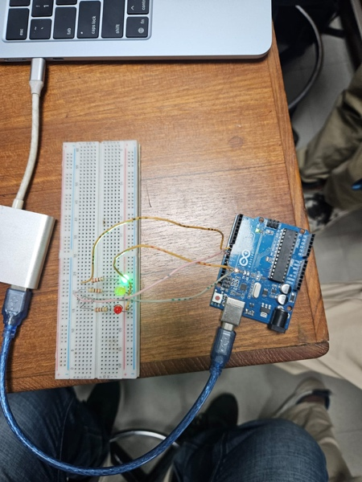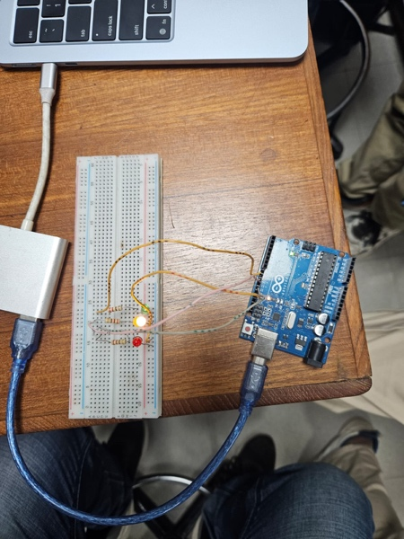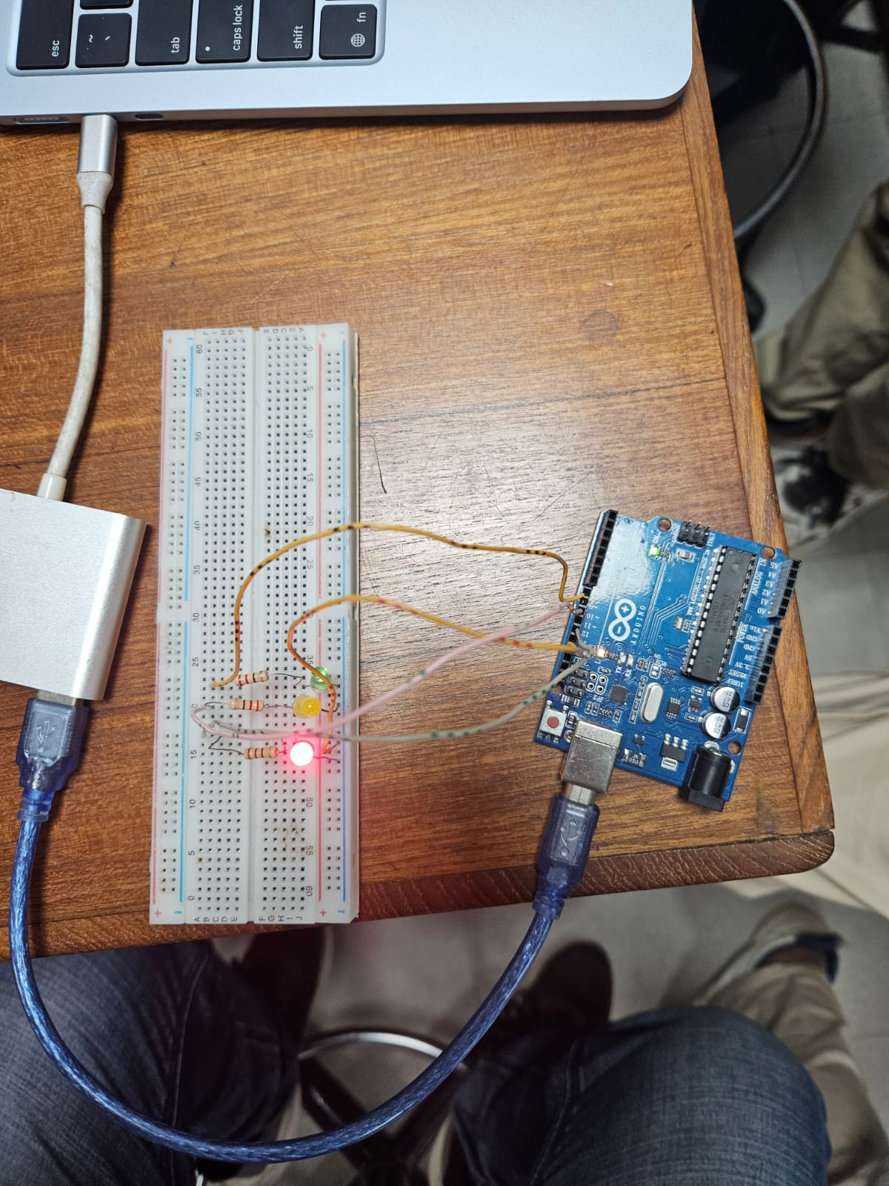

Fig 4: Hardware implementation of the traffic light control system

For the traffic light control system, the green, yellow, and red LEDs were observed to operate sequentially. The green LED remained turned on for the specified duration, followed by the yellow LED blinking multiple times, and finally the red LED turning on for a longer interval. This sequence was continuously repeated, accurately representing the operation of a basic traffic signal system.

The observed hardware outputs matched the expected behavior defined in the programmed logic, indicating successful implementation of the experiment.

**Experimental Output Results:**

The experimental outputs were obtained after successfully uploading the programs to the Arduino Uno Mini microcontroller board and executing them under laboratory conditions. The behavior of the LEDs was observed and analyzed based on the programmed logic.

For the LED blink experiment, the LED connected to the designated digital output pin was observed to switch between ON and OFF states at regular intervals. The timing of the blinking closely followed the delay values defined in the program, confirming proper execution of the control logic and correct functioning of the microcontroller.

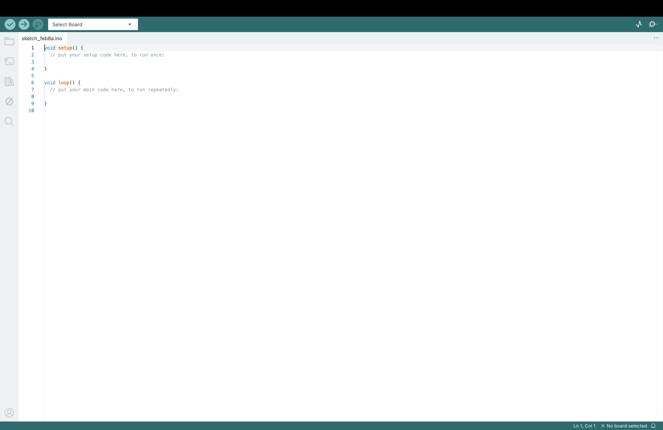

Fig 5: Arduino IDE environment code script area

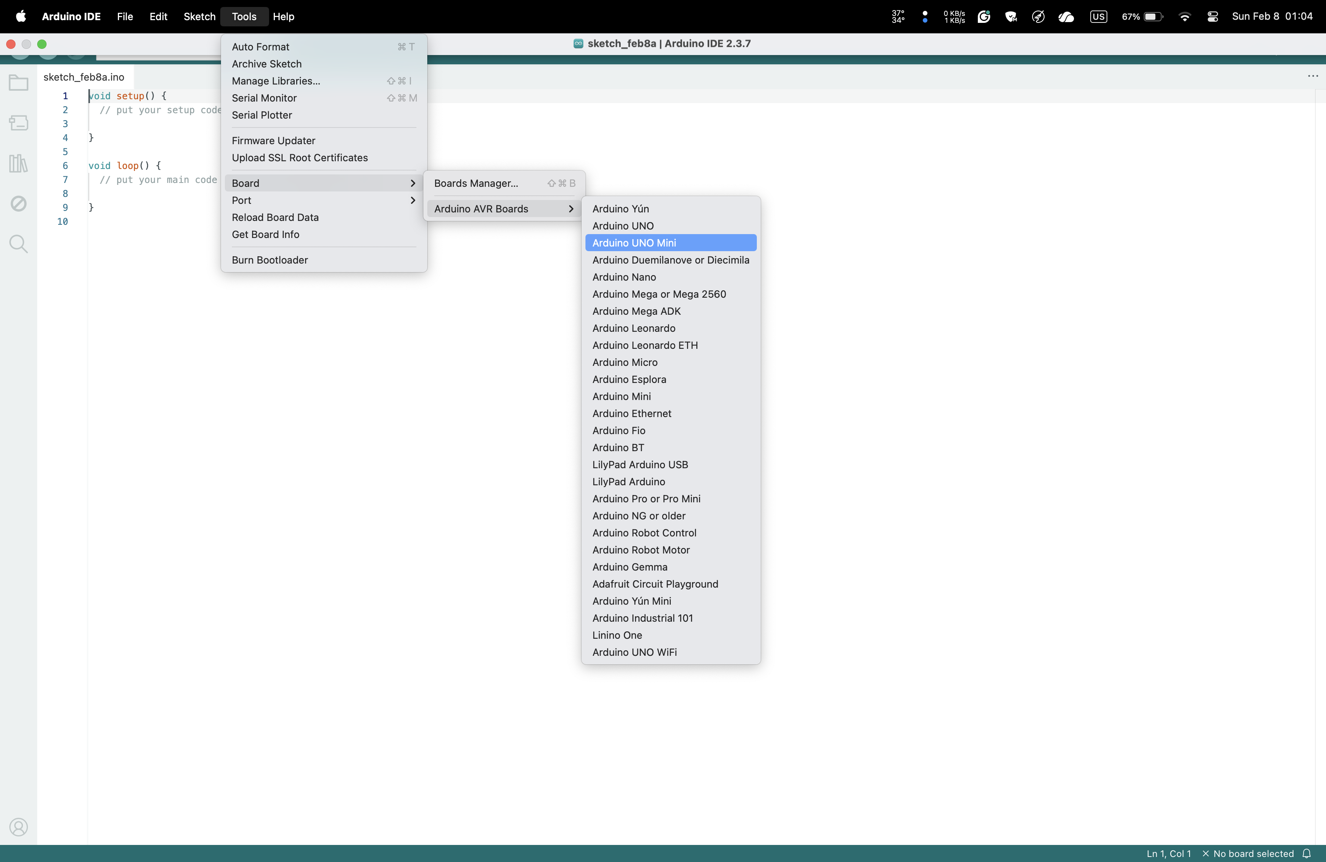

Fig 6: Selection of appropriate board configuration in Arduino IDE

In the traffic light control experiment, the green, yellow, and red LEDs were observed to operate in a sequential manner. The green LED remained active for the specified duration, followed by the yellow LED blinking repeatedly, and finally the red LED turning on for a longer period. This sequence was observed to repeat continuously without interruption.

The experimental outputs were found to be consistent with the expected results and demonstrated the successful implementation of both the LED blinking operation and the traffic light control system.

**Simulation Output Results:**

The simulation of both the LED blink test and the traffic light control system was performed using the TinkerCAD online circuit simulation platform. The simulation environment was used to verify the logical correctness of the programs before and alongside hardware implementation.

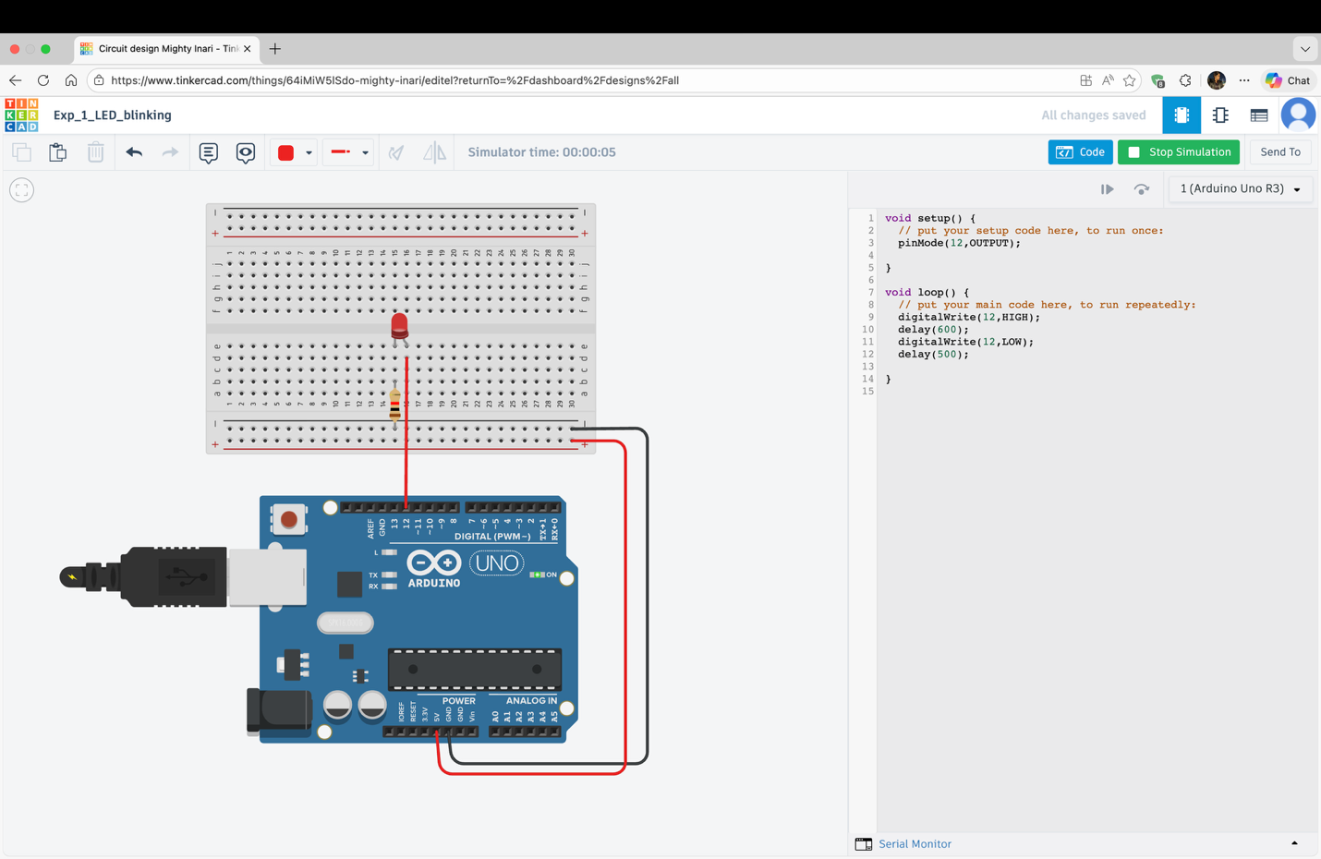

Fig: LED blinking

In the LED blink simulation, the Arduino Uno board was connected to an LED through a current-limiting resistor on a virtual breadboard. After running the simulation, the LED was observed to turn on and off repeatedly according to the programmed delay intervals. The simulated behavior confirmed the correct configuration of the output pin and timing logic.

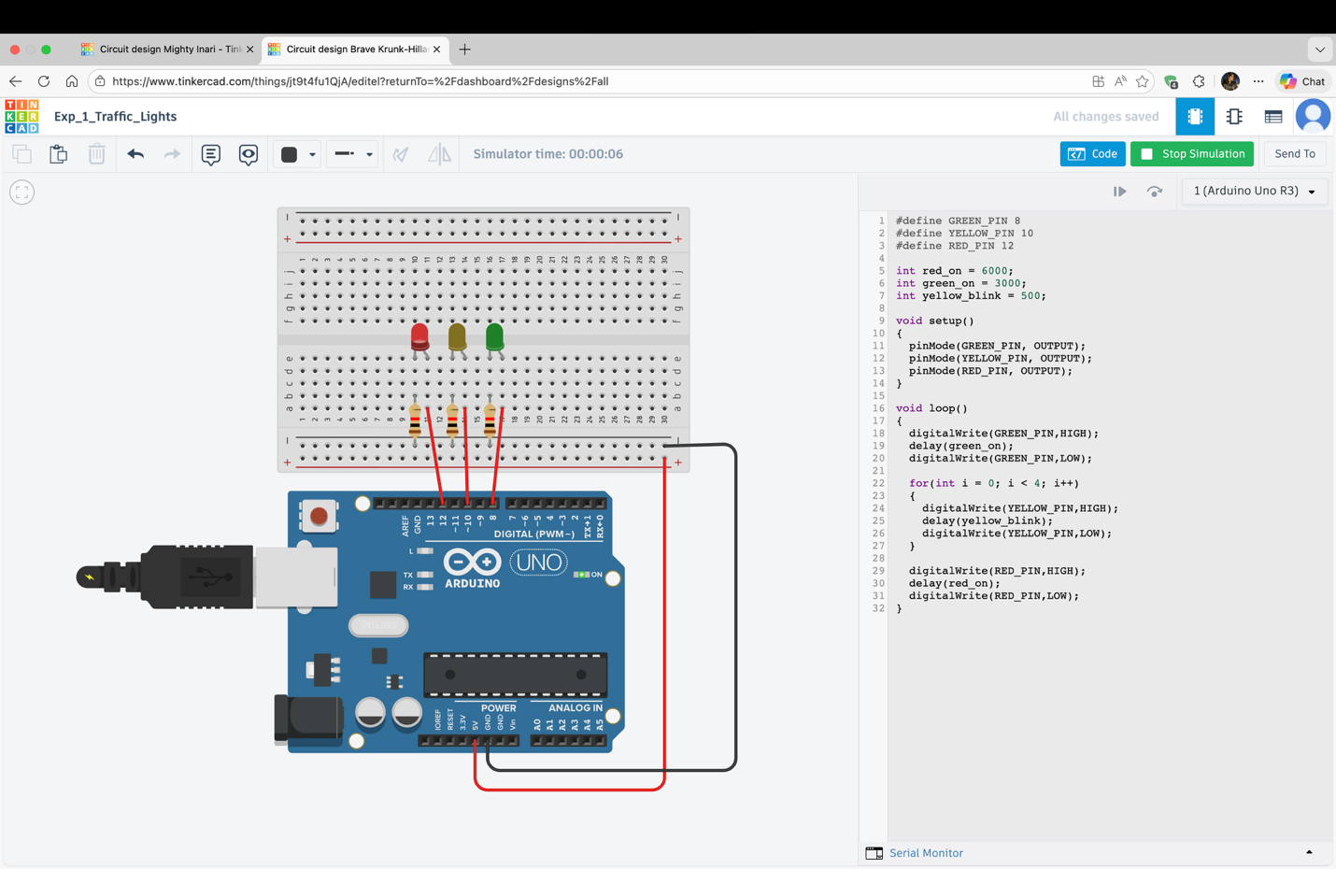

Fig: Traffic Lights

**Answers to the Questions in the Lab Manual:**

1. Include all codes and scripts in the lab report with detailed explanations according to the report writing template given in the portal.

🡺 The answer to this question has been given in the **Code/Program** section of the report.

1. Show the output/results in the form of images. Give their captions and descriptions.

🡺 The answer to this question has been given in the **Hardware Output** section of the report.

1. Include the Proteus simulation of the LED blink program and traffic light control system. Explain the simulation methodology. You may learn the simulation from the following video link: <https://www.youtube.com/watch?v=yHB5it0s2oU>

🡺 The simulations for the experiment have been provided in the Simulation Output Result section of the lab report. [Simulations were done using TinkerCAD]

**Discussion:**

The experiment was successfully carried out to demonstrate the basic operation of an Arduino-based microcontroller system. The LED blink test verified correct digital output control and timing using delay functions, while the traffic light control system demonstrated sequential control of multiple LEDs. The observed outputs were consistent with the programmed logic, indicating proper circuit connections and accurate code execution. The use of defined pin numbers and delay variables improved the clarity and efficiency of the programs. Overall, the experiment effectively reinforced fundamental concepts of microcontroller programming and embedded system implementation.

**References:**

* Arduino. *Arduino Official Website*. Available at: <https://www.arduino.cc/>
* TinkerCAD. Online Circuit Simulation Platform. Available at: <https://www.tinkercad.com/>
* Blum, J. Exploring Arduino: Tools and Techniques for Engineering Wizardry. Wiley Publishing.
* Arduino. Arduino Reference (Documentation). Available at: <https://www.arduino.cc/reference/en/>